Write a C++ program that will accept a text message from a disc file and produce a coded or decoded message.

The code shall use a letter substitution cipher. The letters are identified by the numerical position of the letter ($a→0$, $b→1$, … $z→25$). The $code number$ shall be calculated as follows

$$code number = offset + spacing×(letter number)$$

Where $offset$ is an offset value and $spacing$ gives the spacing between letters. The $code number$ is to “wrap around” so the values will range from 0 to 25. The offset value $offset$ is an integer ranging from 1 to 25. The spacing value $spacing$ is a positive odd integer not greater than $11$. These values are to be based on the number of characters in the message, including spaces, punctuation and other characters. Use the following formulas for these values:

int offset = length % 25 + 1; //returns a value from 1 to 25
int spacing = (length % 6) * 2 + 1;
//returns a positive odd value <= 11

where $length$ is the number of characters in the message.

Implement the code cipher by creating a lookup-table array. This same look-up table is to be used in decoding messages. Revise the input text to contain all lower-case letters. Apply the code to lower case letters only. Write the program to allow the user to choose to encode regular messages and to decode coded messages. Write the encoded and decoded messages to .txt disc files.

Document the program with the following in a PDF file:

A. A written description of the program that describes the purpose of the program and the structure of the program.

B. A flowchart to graphically illustrate the structure of the program.

C. The code listing.

Upload text files for the following:

D. Text files of the input message (in English) and the corresponding coded message (in code words).
- Encoding file 1
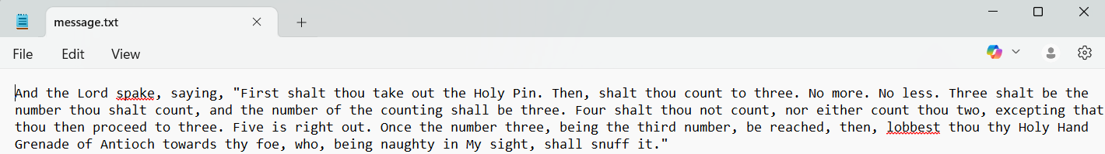

E. Decode the two coded messages and save the decoded massages as text files.
- Decoding file 1
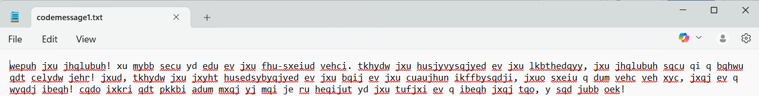

- Decoding file 2
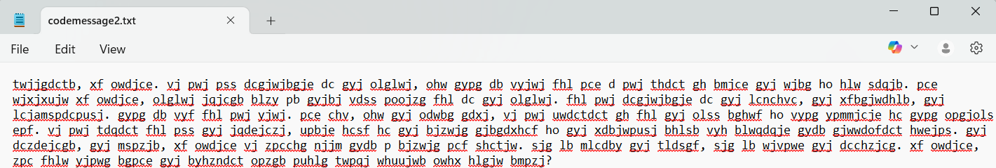

Upload the PDF document and all of the text files to Blackboard.

